Survey 1 Part 1 Responses

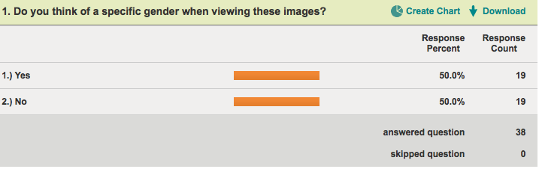

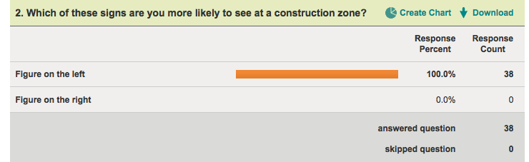

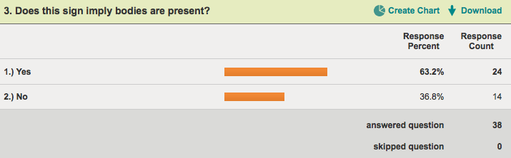

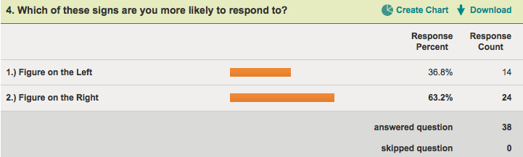

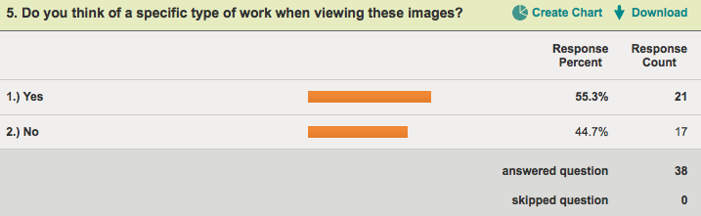

Survey 1 Part 2 Responses

